TYPE TITLE HERE IN ALL CAPS

___________

A Thesis <OR> Dissertation
Presented to
The Faculty of the Department of <Insert Department Name>
Sam Houston State University

___________

In Partial Fulfillment
of the Requirements for the Degree of
Doctor of <insert degree> OR Master of <insert degree>

___________

by
<Your official name as found in the Registrar’s office>
December, 2023

TYPE TITLE HERE IN ALL CAPS

by
<Your official name as found in the Registrar’s office>

___________

APPROVED:
Committee Member Name, PhD
Committee Director <or> Chair

Committee Member Name, PhD
Committee Co-Director <or> Co-Chair

Committee Member Name, PhD
Committee Member

Committee Member Name, PhD
Committee Member

Dean of College Name, PhD
Dean, College of <insert name of college>

This dissertation <or> thesis follows a journal-model format. The name of each journal is indicated on the chapter designation page and adheres to the journal’s specified style and format requirements for manuscript submission, except where superseded by the guidelines of The Graduate and Professional School at Sam Houston State University.

DEDICATION
Start typing your text here. Delete this page if you do not want to use it.

ABSTRACT
Last Name, First Name M., The title of the thesis goes here: Use sentence style capitalization. Master of Arts <or> Doctor of Philosophy (<Insert Major in Parenthesis>), December, 2023, Sam Houston State University, Huntsville, Texas.

This is the format for the bibliographic information required for the abstract. The content of the abstract that follows this citation will vary according to the subject area. The abstract should be concise and informative; however, the abstract must be less than 350 words in length. Students should consult their thesis director and style manual to determine the content of the abstract. In general, it should state the purpose and describe the subjects and the methodology used in the study. The abstract should also describe the findings, conclusions, and implications of the study.
A list of key words must be included at the bottom of the abstract; however, key words and the title information do not count toward the 350-word total. Key words should be specific terms or phrases used in the thesis that would enable a person to successfully search out the content of the document if it were in a library database. If one of the key words is a proper noun, follow the normal rules of capitalization. Likewise, italicize or underline foreign words or appropriate scientific nomenclature. The first word of each key term should be capitalized.
KEY WORDS: Thesis guidelines; Index word; Sam Houston State University; Graduate school; Texas

ACKNOWLEDGEMENTS
Type your text here.

PREFACE
Type your text here.

TABLE OF CONTENTS
Page
DEDICATION iii
ABSTRACT iv
ACKNOWLEDGEMENTS v
PREFACE vi
TABLE OF CONTENTS vii
LIST OF TABLES ix
LIST OF FIGURES x
- INTRODUCTION 1
First Heading Level 2 Subdividing Chapters into Main Sections 1
Here is a Second Major Section within Chapter I 2
- THIS IS THE TITLE FOR CHAPTER II’S JOURNAL ARTICLE 3
Abstract 4
Here is a New Major Section within Chapter II 6
And Here is a Second Major Section within Chapter II 6
References 7
- THIS IS THE TITLE FOR CHAPTER III’S JOURNAL ARTICLE 8
Abstract 9
References 12
- THIS IS THE TITLE FOR CHAPTER IV’S JOURNAL ARTICLE 13
Abstract 14
References 16
- CONCLUSION 17
REFERENCES 18
APPENDIX A 19
APPENDIX B 20
APPENDIX C 21
VITA 22

LIST OF TABLES
Table Page
- This is the Title for Table 1: Ferret Breeders of Ohio, New Jersey, and Washington States 3

LIST OF FIGURES
Figure Page
1 The Figure Title Appears Beneath the Image and Looks Like This in the List of Figures. 5
2 This the Title for the Second Figure in the text, and it Demonstrates the Process that was used for this Experiment. 6

CHAPTER I

INTRODUCTION
This template has pre-formatted font styles that can be found in the Quick Styles gallery under the Home tab. The SectionTitle font style is used to type section titles like Dedication, Appendix, and Vita. (Use the Normal font style to create new Chapter I, II & III section headings, and manually center and bold the text.) Heading 1 is used to type chapter titles that appear directly beneath the section titles, such as Introduction above. Using proper font styles ensures that the Table of Contents, List of Tables, and List of Figures are populated with correct information.

First Heading Level 2 Subdividing Chapters into Main Sections
Type your text here.

Heading Level 3 Subdividing Main Sections into Subsections
Start typing text here. You may need to insert a style divider after the Heading Level 3. You can do this by placing your cursor after the Heading Level 3 and pressing the following buttons at the same time: CTRL + ALT + ENTER. Then you may switch to a different font style such as Normal.
Heading Level 4 subdividing Heading Level 3 sections into subsections.
Start typing your text here.
Heading Level 5 subdividing Heading Level 4 sections into subsections.
Start typing your text here. You do not have to use all of these heading levels in your document. Just remember that you must use them in order. You cannot skip from Heading Level 2 to Heading Level 4.
Also remember that you cannot have a single section or subsection. You must have at least two or more sections or subsections, otherwise you may as well not subdivide the text with a heading. It’s the same concept as creating an outline, if that helps.

Here is a Second Major Section within Chapter I
SDdsf wda dskfj ad akdf kja adkjf i9i en adf sdkfjn.

CHAPTER II

THIS IS THE TITLE FOR CHAPTER II’S JOURNAL ARTICLE

_____________________
This chapter follows the style and format of Title of Journal.

Abstract
Abstracts for individual articles should follow the guidelines for authors found in your chosen journal.

KEY WORDS:

TITLE OF CHAPTER IN ALL CAPS
First Heading (Usually the Introduction)
Starting typing text here. This is the first paragraph of this chapter and contains lots of valuable information about data collected during this research project. Table 1 clearly presents the data collected for this project in a single, easy-to-read format. The author must reference the table before it appears in the text. Use the TableTitle font style found in the Quick Styles gallery on the Home tab to type the table’s title. The table number should be Normal font style that you manually set to the left and bold.
Table 1
This is the Title for Table 1: Ferret Breeders of Ohio, New Jersey, and Washington States
 | State | Membership Association | Bloodlines
Fire Storm Ferrets | Ohio | American Ferret Association  Heart of Ohio Ferret Association | American  Australian  Swedish  English  German
Four Paws Wrecking Crew Ferretry | Ohio |  | German  Finnish  English
Fuzzy Loving Ferrets | New Jersey |  | French  Danish  Austrian  Finnish  Scottish  English  German  Swedish  New Zealand  Russian  Welsh  Norwegian  Canadian  Angora
Note. Notes for tables go beneath the tables and may be single-spaced to help differentiate them from regular text.
Tables should be cleanly formatted with the fewest number of horizontal and vertical lines used to separate the elements. Font size and spacing within a table can be adjusted to help with spacing issues or to keep a table on one page, as long as the text remains readable.

Here is a New Major Section within Chapter II
Skdkn dsfrj sedkj ksdf k sdkdfsk sef sdkf sdk sdf kksdf sd.

And Here is a Second Major Section within Chapter II
Jsdfkjdss sdklfj sdoioewk o32kmd ksdk90 ksdk .

References
**List references cited in this chapter only.**

CHAPTER III

THIS IS THE TITLE FOR CHAPTER III’S JOURNAL ARTICLE

_____________________
This chapter follows the style and format of Title of Journal.

Abstract
Abstracts for individual articles should follow the guidelines for authors found in your chosen journal.

KEY WORDS:

TITLE OF CHAPTER IN ALL CAPS
First Heading (Usually the Introduction)
Starting typing text here. This is the first paragraph of this chapter and contains lots of valuable information about data collected during this research project. Figure 1 demonstrates a part of the research process. The author must reference the figure before it appears in the text. Use the FigureTitle font style found in the Quick Styles gallery on the Home tab to type the figure’s title. The figure number should be Normal font style that you manually set to the left and bold.
Figure 1
The Figure Title appears Beneath the Image and Looks like this in the List of Figures
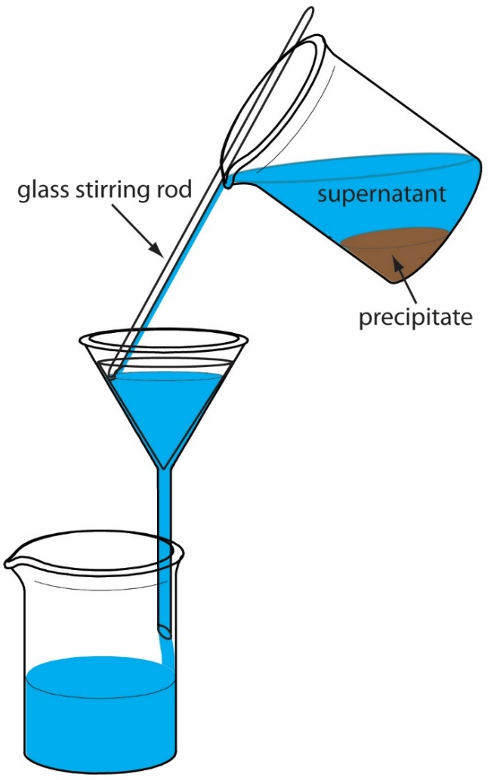
Note. Notes are typed immediately after the caption. Captions and notes can be single spaced to help differentiate them from the rest of the test. You may also need to press CTRL + ALT + ENTER to separate the different font styles from each other on the same line.
Figure 2

This the Title for the Second Figure in the Text, and it Demonstrates the Process that was used for this Experiment

Note.
This is the note.

References
**List references cited in this chapter only.**

CHAPTER IV

THIS IS THE TITLE FOR CHAPTER IV’S JOURNAL ARTICLE

_____________________
This chapter follows the style and format of Title of Journal.

Abstract
Abstracts for individual articles should follow the guidelines for authors found in your chosen journal.

KEY WORDS:

TITLE OF CHAPTER IN ALL CAPS
First Heading (Usually the Introduction)
Starting typing text here.

References
**List references cited in this chapter only.**

CHAPTER V

CONCLUSION

REFERENCES
**This is the main references section. List ALL references cited in the entire document**

APPENDIX A
Appendixes serve as repositories for materials that help clarify your research, but do not belong in the main text. It is not required to include an Appendix. Include one or more only if you need to.
Items that might be included:
- Letters granting permission to reproduce or adapt images, instruments for research, or other copyrighted materials in your thesis/dissertation.
- Copies of IRB’s.
- Survey questionnaires that you have created.
- Tables, figures, or instruments that do not belong in the main text.

APPENDIX B

APPENDIX C

VITA
A vita is the equivalent of a resume, and is used to list your educational and professional qualifications. There is no required format for this style. Instead, you may arrange the contents in the manner that best suits your academic field as long as the general format for theses and dissertations is followed.
Your vita may follow one of two formats:
•Narrative
•Traditional CV (resume) style

If any article has been previously published in an academic journal. Add a footnote to the title and list the full citation in your chosen style guide here.

